Install Android Studio
Setting up Android Studio takes just a few clicks.
First, be sure you download the latest version of Android Studio.

Windows
To install Android Studio on Windows, proceed as follows:
- If you downloaded an .exe file (recommended), double-click to launch it.
If you downloaded a .zip file, unpack the ZIP, copy the android-studio folder into your Program Files folder, and then open the android-studio > bin folder and launch studio64.exe (for 64-bit machines) or studio.exe (for 32-bit machines).
- Follow the setup wizard in Android Studio and install any SDK packages that it recommends.
That's it. The following video shows each step of the setup procedure when using the recommended .exe download.
As new tools and other APIs become available, Android Studio tells you with a pop-up, or you can check for updates by clicking Help > Check for Update.

Mac
To install Android Studio on your Mac, proceed as follows:
- Launch the Android Studio DMG file.
- Drag and drop Android Studio into the Applications folder, then launch Android Studio.
- Select whether you want to import previous Android Studio settings, then click OK.
- The Android Studio Setup Wizard guides you through the rest of the setup, which includes downloading Android SDK components that are required for development.
That's it. The following video shows each step of the recommended setup procedure.
As new tools and other APIs become available, Android Studio tells you with a pop-up, or you can check for updates by clicking Android Studio > Check for Updates.

Linux
To install Android Studio on Linux, proceed as follows:
- Unpack the .zip file you downloaded to an appropriate location for your applications, such as within /usr/local/ for your user profile, or /opt/ for shared users.
- To launch Android Studio, open a terminal, navigate to the android-studio/bin/ directory, and execute studio.sh.
- Select whether you want to import previous Android Studio settings or not, then click OK.
- The Android Studio Setup Wizard guides you through the rest of the setup, which includes downloading Android SDK components that are required for development.
Tip: To make Android Studio available in your list of applications, select Tools > Create Desktop Entry from the Android Studio menu bar.
Required libraries for 64-bit machines:
If you are running a 64-bit version of Ubuntu, you need to install some 32-bit libraries with the following command:
sudo apt-get install libc6:i386 libncurses5:i386 libstdc++6:i386 lib32z1 libbz2-1.0:i386
If you are running 64-bit Fedora, the command is:
sudo yum install zlib.i686 ncurses-libs.i686 bzip2-libs.i686
That's it. The following video shows each step of the recommended setup procedure.
As new tools and other APIs become available, Android Studio tells you with a pop-up, or you can check for updates by clicking Help > Check for Update.

Chrome OS
Follow these steps to install Android Studio on Chrome OS:
- If you haven't already done so, install Linux for Chrome OS.
- Download the Chrome OS DEB package from the Preview release page.
- Open the Files app and locate the DEB package in the Downloads folder under My files.
- Right-click the DEB package and select Install with Linux (Beta).
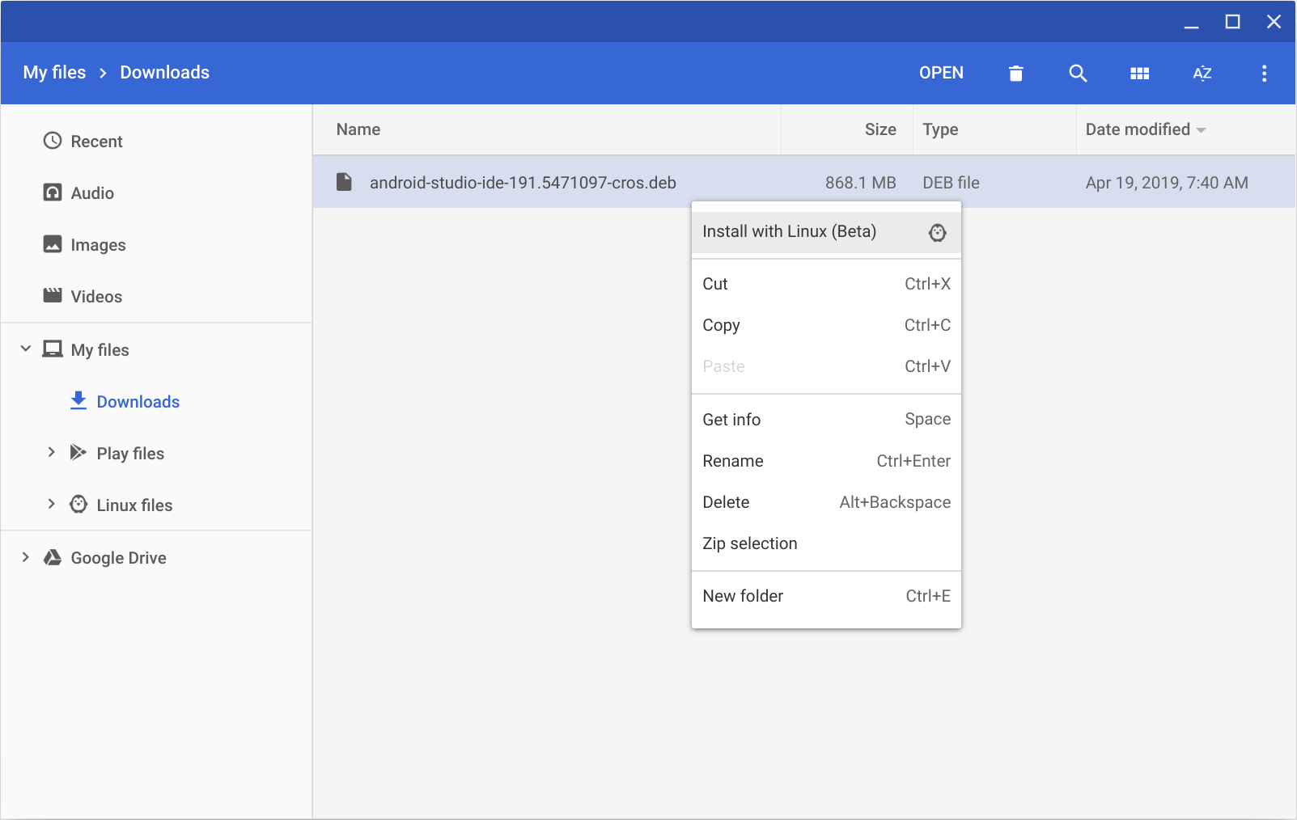
- Select whether you want to import previous Android Studio settings, then click OK.
- The Android Studio Setup Wizard guides you through the rest of the setup, which includes downloading Android SDK components that are required for development.
- After installation is complete, launch Android Studio either from the Launcher, or from the Chrome OS Linux terminal by running studio.sh in the default installation directory:
/opt/android-studio/bin/studio.sh
That's it. As new tools and other APIs become available, Android Studio tells you with a pop-up, or you can check for updates by clicking Help > Check for Update.

